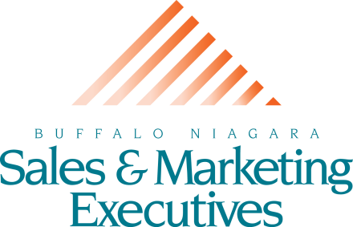

FOR IMMEDIATE RELEASE June 7, 2021

For more information, contact: Jeanne Hellert
BNSME
716-662-2279
bnsme@bnsme.org

BNSME'S 25th ANNUAL GOLF TOURNAMENT
DONATES $8,000 TO JUNIOR ACHIEVEMENT OF WNY

April 26, 2021, Buffalo, NY - Buffalo Niagara Sales and Marketing Executives is proud to announce the proceeds from their 25th Annual Golf Outing in August 2020, in the amount of $8,000, was donated to Junior Achievement of WNY. Junior Achievement of WNY’s mission is to inspire and prepare young people to succeed in a global economy to improve the quality of their lives. JA’s Financial Literacy, Entrepreneurship and Work & Career Readiness Pathways become a continuum of progressive learning experiences, each inspiring, preparing, and ultimately inspiring students from Kindergarten to 12th grade to acquire and demonstrate the competencies needed to be financially capable, work and career ready, and/or entrepreneurially minded.

Jeanne Hellert, the executive director of BNSME states, "This was a particularly special year for BNSME to make this donation to JA. Due to the pandemic, we did not know if we would have the opportunity to still hold our golf outing and raise the needed funds. Like so many organizations in our community, we are consistently amazed by the generosity of our WNY business community. BNSME is proud of our ongoing partnership with Junior Achievement of WNY and to help our students.”

“BNSME is not only a strong partner during the annual golf outing, but also provides the classroom volunteers and strategic collaborations among our respective Board of Directors. Junior Achievement of WNY is proud to maintain our relationship with BNSME for 25 years and we look forward to future collaborations.” Lisa Roy, Senior Development Manager, Junior Achievement.

The 26th Annual Golf Outing, presented by Northwestern Mutual, is taking place on Monday, June 21, 2021. Golf spots are still available. Please visit bnsme.org for full event details.

###

About the Buffalo/Niagara Sales & Marketing Executives:
Since 1942, the Buffalo Niagara Sales and Marketing Executives (BNSME) have been devoted to professionalism in sales and marketing. BNSME provides a unique forum for Greater Buffalo Niagara business leaders to further their professional and personal development through interaction with experts in sales and marketing by sharing ideas, best practices, knowledge, and experience.

Junior Achievement is the world's largest organization dedicated to educating students in grades K-12 about financial literacy, entrepreneurship and work readiness through experiential, digitaland hands-on programs. JA of WNY enriches the lives of more than 16,000 students in 174 schools and community organizations throughout the eight counties of Western New York. JA’s success is due to its many generous supporters and more than 745 volunteers. For more information about Junior Achievement and how you can make a difference in a student’s life, contact Lisa Roy at 716-853-1381, ext. 212 Lroy@jawny.org, or visit our Web site at www.jawny.org.

